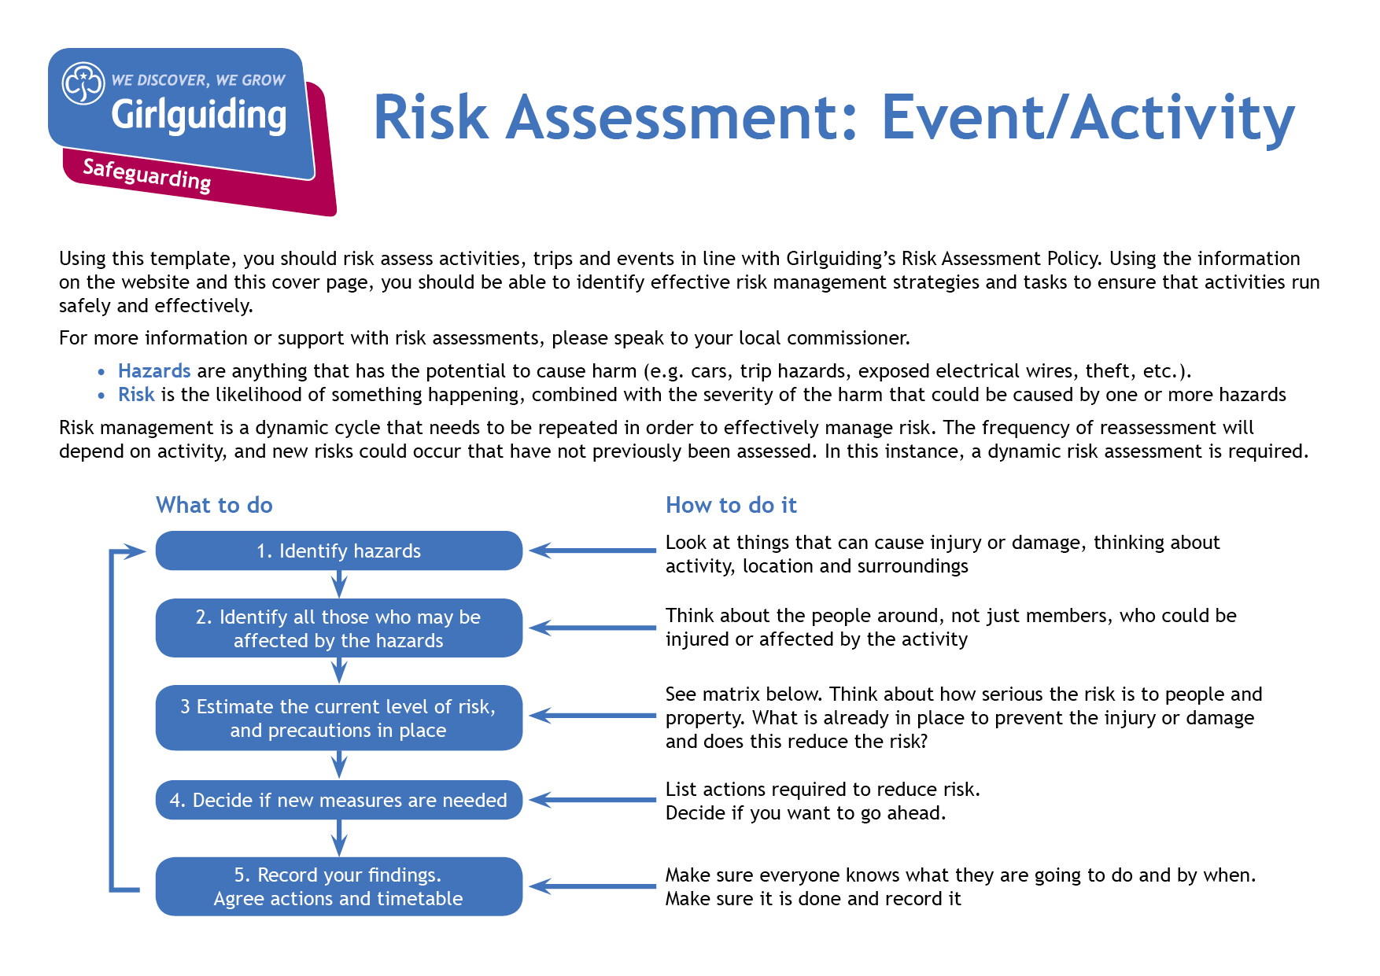
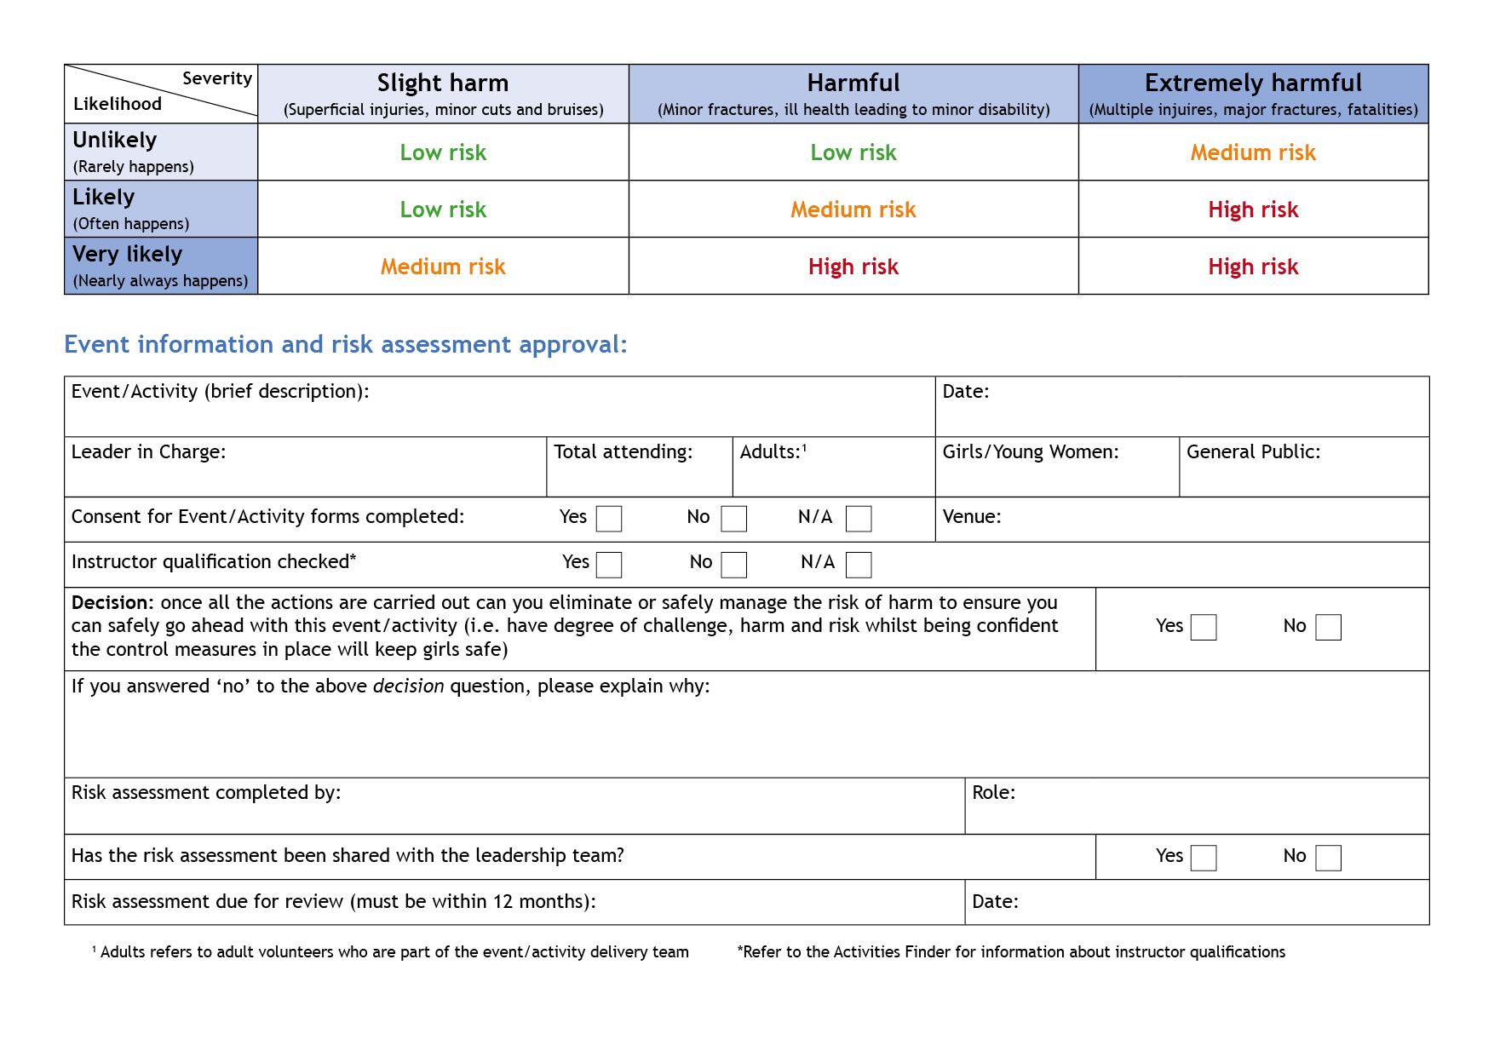

Big Help Out working party

X

X
X

Day before visit

Unit meeting place
-
Unit team
As in unit
Unit Leader
1 potential volunteer
Various
Visits by potential adult volunteers to unit meetings
Hazards  What could cause harm or damage? | Who or what is at risk of being affected and how? | What are you already doing?  How have you reduced the risk already? | Likelihood of risk occurring  (L/M/H) | Severity of risk  (L/M/H) | Are further controls necessary?  What else needs to happen to reduce the risk to an acceptable level? | Action by:  name/date
Unit leader to read the information on visitors to unit meetings and act on it.

Visitors to your meetings | Girlguiding

Unit safeguarding guidelines | Girlguiding
Unknown member of public visiting unit meeting | Unit members – personal harm | Invite in one person only at a time.  Either assign one adult in your unit team to welcome and shadow the visitor, or invite in an additional trusted volunteer do this.  Visitor not to be left alone with under-18s at any time.  Unit leader to send visitor the External Visitors Form (downloaded from external-visitors-form.docx (live.com)) in advance. Completed form to be returned to unit leader in advance. | L | H
Visitor unaware of acceptable behaviour during unit meeting | Visitor – reputational risk | Unit leader to send visitor the unit safeguarding guidelines (downloaded from Unit safeguarding guidelines | Girlguiding) in advance. | L | M | Have a copy of the unit safeguarding guidelines available at the unit meeting and check with the visitor on arrival that they have read it. Answer any questions they may have or confirm that they have understood the information.
Visitors turn up unannounced | All | In the app entry, state only the meeting day and the approximate location. Visitors need to register to obtain additional information.  Limit sign-up capability to 1 person for each event (is this possible?). | L | L
Need to provide contact details for unit | Girlguiding member – release of personal information | Set up a unit email address (or a dedicated email address) for use as the contact email in the app. Do not share any other contact information. | L | M
Poor quality information provided in app to offer opportunity | Girlguiding – reputational risk | Provide guidance on branding and template text for units to use to fit in with Girlguiding’s new way of talking about itself. | L | L

